**Practical 1: Introduction AWS Platform and Services.**

**Solution:**

In 2006, Amazon Web Services (AWS) started to offer IT services to the market in the form of web services, which is nowadays known as cloud computing. With this cloud, we need not plan for servers and other IT infrastructure which takes up much of time in advance. Instead, these services can instantly spin up hundreds or thousands of servers in minutes and deliver results faster. We pay only for what we use with no up-front expenses and no long-term commitments, which makes AWS cost efficient. Today, AWS provides a highly reliable, scalable, low-cost infrastructure platform in the cloud that powers multitude of businesses in 190 countries around the world.

**What is Cloud Computing?**

Cloud computing is an internet-based computing service in which large groups of remote

servers are networked to allow centralized data storage, and online access to computer

services or resources.

Using cloud computing, organizations can use shared computing and storage resources

rather than building, operating, and improving infrastructure on their own.

Cloud computing is a model that enables the following features.

* Users can provision and release resources on-demand.
* Resources can be scaled up or down automatically, depending on the load.
* Resources are accessible over a network with proper security.
* Cloud service providers can enable a pay-as-you-go model, where customers are charged based on the type of resources and per usage.

**Types of Clouds**

There are three types of clouds - Public, Private, and Hybrid cloud.

* **Public Cloud**

In public cloud, the third-party service providers make resources and services available to their customers via Internet. Customer’s data and related security is with the service providers’ owned infrastructure.

* **Private Cloud**

A private cloud also provides almost similar features as public cloud, but the data and

services are managed by the organization or by the third party only for the customer’s

organization. In this type of cloud, major control is over the infrastructure so security

related issues are minimized.

* **Hybrid Cloud**

A hybrid cloud is the combination of both private and public cloud. The decision to run on private or public cloud usually depends on various parameters like sensitivity of data and applications, industry certifications and required standards, regulations, etc.

**Cloud Service Models**

There are three types of service models in cloud - IaaS, PaaS, and SaaS.

* **IaaS**

IaaS stands for Infrastructure as a Service. It provides users with the capability to

provision processing, storage, and network connectivity on demand. Using this service model, the customers can develop their own applications on these resources.

* **PaaS**

PaaS stands for Platform as a Service. Here, the service provider provides various

services like databases, queues, workflow engines, e-mails, etc. to their customers. The customer can then use these components for building their own applications. The services, availability of resources and data backup are handled by the service provider that helps the customers to focus more on their application's functionality.

* **SaaS**

SaaS stands for Software as a Service. As the name suggests, here the third-party

providers provide end-user applications to their customers with some administrative

capability at the application level, such as the ability to create and manage their users.

Also some level of customizability is possible such as the customers can use their own

corporate logos, colors, etc.

**Advantages of Cloud Computing**

Here is a list of some of the most important advantages that Cloud Computing has to offer:

1. Cost-Efficient:

Building our own servers and tools is time-consuming as well as

expensive as we need to order, pay for, install, and configure expensive hardware,

long before we need it. However, using cloud computing, we only pay for the

amount we use and when we use the computing resources. In this manner, cloud

computing is cost efficient.

1. Reliability:

A cloud computing platform provides much more managed, reliable

and consistent service than an in-house IT infrastructure. It guarantees 24x7 and

365 days of service. If any of the server fails, then hosted applications and services

can easily be transited to any of the available servers.

1. Unlimited Storage:

Cloud computing provides almost unlimited storage capacity, i.e., we need not worry about running out of storage space or increasing our current storage space availability. We can access as much or as little as we need.

1. Backup & Recovery: Storing data in the cloud, backing it up and restoring the

same is relatively easier than storing it on a physical device. The cloud service providers also have enough technology to recover our data, so there is the convenience of recovering our data anytime.

1. Easy Access to Information: Once you register yourself in cloud, you can access

your account from anywhere in the world provided there is internet connection at

that point. There are various storage and security facilities that vary with the

account type chosen.

**Disadvantages of Cloud Computing**

Although Cloud Computing provides a wonderful set of advantages, it has some drawbacks

as well that often raise questions about its efficiency.

1. Security issues

Security is the major issue in cloud computing. The cloud service providers implement the

best security standards and industry certifications, however, storing data and important

files on external service providers always bears a risk.

AWS cloud infrastructure is designed to be the most flexible and secured cloud network.

It provides scalable and highly reliable platform that enables customers to deploy

applications and data quickly and securely.

1. Technical issues

As cloud service providers offer services to number of clients each day, sometimes the

system can have some serious issues leading to business processes temporarily being

suspended. Additionally, if the internet connection is offline then we will not be able to

access any of the applications, server, or data from the cloud.

1. Not easy to switch service providers

Cloud service providers promises vendors that the cloud will be flexible to use and

integrate, however switching cloud services is not easy. Most organizations may find it

difficult to host and integrate current cloud applications on another platform.

Interoperability and support issues may arise such as applications developed on Linux

platform may not work properly on Microsoft Development Framework (.Net).

**2. AWS ─ Basic Architecture**

This is the basic structure of AWS EC2, where EC2 stands for Elastic Compute Cloud. EC2

allow users to use virtual machines of different configurations as per their requirement. It

allows various configuration options, mapping of individual server, various pricing options,

etc. We will discuss these in detail in AWS Products section. Following is the diagrammatic

representation of the architecture.

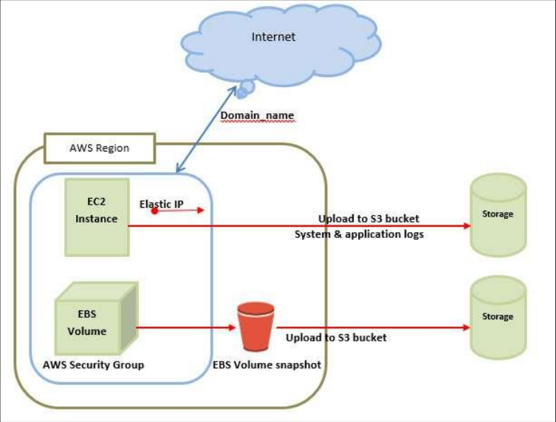

Note: In the above diagram S3 stands for Simple Storage Service. It allows the users to

store and retrieve various types of data using API calls. It doesn’t contain any computing

element. We will discuss this topic in detail in AWS products section.

**Load Balancing**

Load balancing simply means to hardware or software load over web servers, that

improvers the efficiency of the server as well as the application. Following is the

diagrammatic representation of AWS architecture with load balancing.

Hardware load balancer is a very common network appliance used in traditional web

application architectures.